**Online dairy**

**Digital to Physical**

**8.0 Introduction**

The task was to convert a digital gam into a physical rendition of itself. As a team we settled on fire emblem as most of us had played the game and the game itself can easily be converted into a physical game as it is a tactical role-playing game. We still chose one specific game from the fire emblem franchise which fire emblem awakening(<https://en.wikipedia.org/wiki/Fire_Emblem_Awakening>). This was because each fire emblem game was different and had different mechanics.

**8.1 Rules**

* Each player is given 12 units
* Each player is given 4 of each class, Mage, knight and cavalry
* One knight must be chosen as the commander and will be given double dice roll and 5 health
* Knights are given 30 health; Cavalry are given 25 and Mages have 15 health
* There is a weapon triangle. Mages>knights, Knights>Cavalry, Cavalry>Mage.
* When attacking players will roll a d6 dice. The number given will be the damage output, however if the unit is stronger against its opponent players can role another D6 and add that to the score.
* Normal units can move 3 spaces, but Cavalry can move 5 spaces.
* Mages can attack from 4 spaces away.
* To win the commander must be defeated.

**8.2 What was changed**

We tried to keep as much as we could from the original game however character classes were cut as well as synchronised attacks. To make more convenient for players we also decreased the movement of characters to fit a physical version. Another that was added was the damage modifier using a D6 dice as normally in the physical it is a computer that calculates the modifier.

**8.4 Resources**

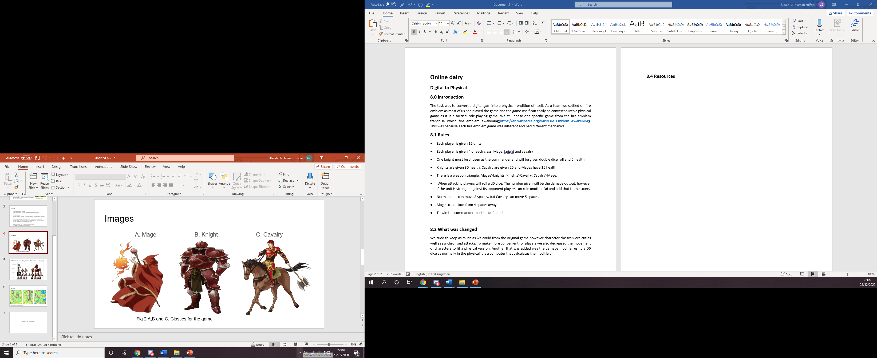

**Figure 1: Classes**

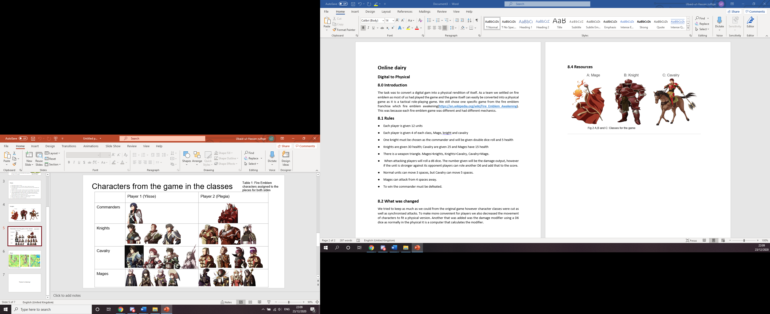

**Figure 2: Character names**

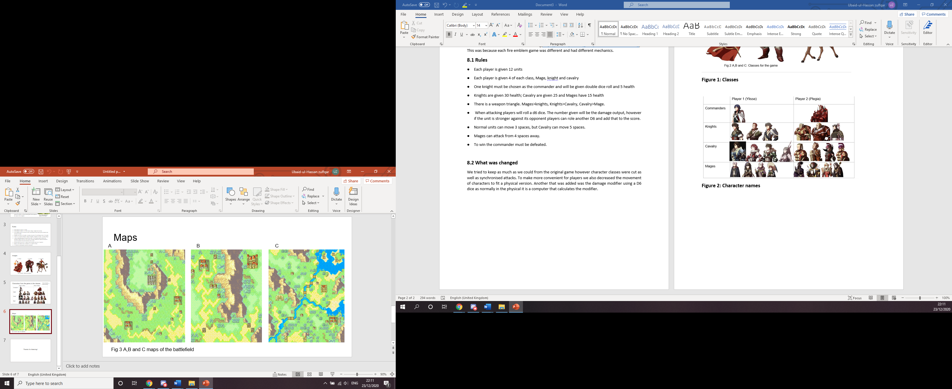

**Figure 3: Maps of the game**

**8.5 Playtesting**

Unfortunately, no playtesting was done. However, we did discuss our game with another group, and it was received with positive feedback. They really liked the idea of conquest on a continent.

**8.6 Reflection**

We worked well as a team. Everyone was given a role and they completed that task. Time management must be looked at as we did not have enough time for playtesting. As a team we were able to efficiently convert this digital game into a physical by adding and changing a few things but at the same time keeping the key element of the game. Some of the team did not know the game but those who did were happy to explain what the game was and how it functioned. As well time management, one other thing that needs to improve is punctuality as a couple of team members did not turn up on time.

